上 海 电 力 大 学

面向对象程序设计(JAVA)-实验报告
（2025/2026学年第2学期）

课程编号 2505190
课程名称 面向对象程序设计(JAVA)
院 （系） 人工智能学部
专 业 计算机科学与技术
班 级 2025051
学 号 20251916
姓 名 张鸿毅
实验名称 实验四 异常处理(7)
任课老师 张挺

实验四 异常处理(7)
1【实验目的】
初步掌握JAVA的类与对象。
2【实验内容】
题目1：电子产品继承体系
要求：
- 设计一个ElectronicDevice类（电子设备）：
  - public String brand（公共，品牌）
  - protected String model（受保护，型号）
  - int power（友好，功率，单位瓦特）
  - private double price（私有，价格）
  - 构造方法初始化所有属性。
  - public void turnOn()：输出“{brand} {model} is turning on.”
  - public void turnOff()：输出“{brand} {model} is turning off.”
  - public void showSpecs()：输出品牌、型号、功率、价格。
- 设计Laptop类（笔记本电脑）继承ElectronicDevice：
  - private int ramSize（私有，内存大小GB）
  - private int storageSize（私有，存储大小GB）
  - double screenSize（友好，屏幕尺寸英寸）
  - 构造方法初始化。
  - 重写turnOn()：先调用父类turnOn()，再输出“Loading OS...”
  - 重写showSpecs()：先调用父类showSpecs()，再输出内存、存储、屏幕尺寸。
  - 提供void openLid()：输出“Lid opened.”
- 设计Smartphone类（智能手机）继承ElectronicDevice：
  - private int cameraMegapixels（私有，摄像头像素）
  - private boolean has5G（私有，是否支持5G）
  - String color（友好，颜色）
  - 构造方法初始化。
  - 重写turnOff()：先输出“Saving data...”，再调用父类turnOff()。
  - 重写showSpecs()：先调用父类showSpecs()，再输出摄像头像素、5G支持、颜色。
  - 提供void takePhoto()：输出“Taking photo with {cameraMegapixels}MP camera.”
- 在测试类的main方法中：
  - 创建Laptop对象（品牌“Dell”，型号“XPS15”，功率130W，价格9999元，内存16GB，存储512GB，屏幕15.6英寸）。
  - 创建Smartphone对象（品牌“Apple”，型号“iPhone15”，功率20W，价格6999元，摄像头48MP，支持5G true，颜色“Black”）。
  - 分别调用turnOn()、showSpecs()、turnOff()。
  - 对Laptop调用openLid()，对Smartphone调用takePhoto()。
示例输出：
--- Laptop ---
Dell XPS15 is turning on.
Loading OS...
Brand: Dell, Model: XPS15, Power: 130W, Price: 9999.0
RAM: 16GB, Storage: 512GB, Screen: 15.6 inches
Lid opened.
Dell XPS15 is turning off.

--- Smartphone ---
Apple iPhone15 is turning on.
Brand: Apple, Model: iPhone15, Power: 20W, Price: 6999.0
Camera: 48MP, 5G: true, Color: Black
Taking photo with 48MP camera.
Saving data...
Apple iPhone15 is turning off.
题目2：交通工具继承体系
要求：
- 设计一个Vehicle类（交通工具）：
  - public String ownerName（公共，车主姓名）
  - protected String licensePlate（受保护，车牌号）
  - int wheels（友好，轮子数量）
  - private double fuelCapacity（私有，燃料容量，单位升）
  - 构造方法初始化所有属性。
  - public void start()：输出“{ownerName}'s vehicle is starting.”
  - public void stop()：输出“Vehicle is stopping.”
  - public void showDetails()：输出车主、车牌、轮子数、燃料容量。
- 设计Car类（汽车）继承Vehicle：
  - private String transmissionType（私有，变速箱类型，如“Automatic”）
  - private int seatCount（私有，座位数）
  - boolean hasSunroof（友好，是否有天窗）
  - 构造方法初始化。
  - 重写start()：输出“{ownerName}'s car engine roars to life.”
  - 重写showDetails()：先调用父类showDetails()，再输出变速箱、座位数、天窗信息。
  - 提供void honk()：输出“Beep beep!”
- 设计Motorcycle类（摩托车）继承Vehicle：
  - private boolean hcasSidecar（私有，是否有侧斗）
  - private int engineCC（私有，发动机排量cc）
  - String type（友好，类型如“Sport”）
  - 构造方法初始化。
  - 重写stop()：输出“Motorcycle brakes screech!”后调用父类stop()。
  - 重写showDetails()：先调用父类showDetails()，再输出侧斗、排量、类型。
  - 提供void wheelie()：输出“Doing a wheelie!”
- 在测试类的main方法中：
  - 创建Car对象（车主“Alice”，车牌“京A12345”，轮子4，燃料容量50L，变速箱“Automatic”，座位5，有天窗true）。
  - 创建Motorcycle对象（车主“Bob”，车牌“沪B67890”，轮子2，燃料容量15L，无侧斗false，排量600cc，类型“Cruiser”）。
  - 分别调用start()、showDetails()、stop()。
  - 对Car调用honk()，对Motorcycle调用wheelie()。
示例输出：
--- Car ---
Alice's car engine roars to life.
Owner: Alice, Plate: 京A12345, Wheels: 4, Fuel: 50.0L
Transmission: Automatic, Seats: 5, Sunroof: true
Beep beep!
Vehicle is stopping.

--- Motorcycle ---
Bob's vehicle is starting.
Owner: Bob, Plate: 沪B67890, Wheels: 2, Fuel: 15.0L
Sidecar: false, Engine: 600cc, Type: Cruiser
Motorcycle brakes screech!
Vehicle is stopping.
Doing a wheelie!

3【实验步骤和结果】(含源码和界面截图)
1.
package Practice.Device;
public class ElectronicDevice
{
public String brand;
protected String model;
int power;
private double price;

public ElectronicDevice(String brand, String model, int power, double price)
{
this.brand = brand;
this.model = model;
this.power = power;
this.price = price;
}

public void turnOn()
{
System.out.println(brand + " " + model + " is turning on.");
}

public void turnOff()
{
System.out.println(brand + " " + model + " is turning off.");
}

public void showSpecs()
{
System.out.println("品牌：" + brand);
System.out.println("型号：" + model);
System.out.println("功率：" + power + 'W');
System.out.println("价格：" + price);
}
}

package Practice.Device;
public class Laptop extends ElectronicDevice
{
private int ramSize;
private int storageSize;
double screenSize;

public Laptop(String brand, String model, int power, double price, int ramSize, int storageSize, double screenSize)
{
super(brand, model, power, price);
this.ramSize = ramSize;
this.storageSize = storageSize;
this.screenSize = screenSize;
}

@Override
public void turnOn()
{
super.turnOn();
System.out.println("Loading OS...");
}

@Override
public void showSpecs()
{
super.showSpecs();
System.out.println("内存：" + ramSize + "GB");
System.out.println("存储：" + storageSize + "GB");
System.out.println("屏幕尺寸：" + screenSize + " inches");
}

public void openLid()
{
System.out.println("Lid opened.");
}
}

package Practice.Device;
public class Smartphone extends ElectronicDevice
{
private int cameraMegapixels;
private boolean has5G;
String color;

public Smartphone(String brand, String model, int power, double price, int cameraMegapixels, boolean has5G, String color)
{
super(brand, model, power, price);
this.cameraMegapixels = cameraMegapixels;
this.has5G = has5G;
this.color = color;
}

@Override
public void turnOff()
{
System.out.println("Saving data...");
super.turnOff();
}

@Override
public void showSpecs()
{
super.showSpecs();
System.out.println("摄像头像素：" + cameraMegapixels + "MP");
System.out.println("5G支持：" + has5G);
System.out.println("颜色：" + color);
}

public void takePhoto()
{
System.out.println("Taking photo with " + cameraMegapixels + " MP camera.");
}
}

package Practice.Test;

import Practice.Device.Laptop;
import Practice.Device.Smartphone;

public class DeviceTest
{
public static void main(String[] args)
{
Laptop laptop1 = new Laptop("Dell", "XPS15", 130, 9999, 16, 512, 15.6);
Smartphone phone1 = new Smartphone("Apple", "iPhone15", 20, 6999, 48, true, "Black");

System.out.println("\n--- Laptop ---");
laptop1.turnOn();
laptop1.showSpecs();
laptop1.openLid();
laptop1.turnOff();

System.out.println("\n--- Smartphone ---");
phone1.turnOn();
phone1.showSpecs();
phone1.takePhoto();
phone1.turnOff();
}
}
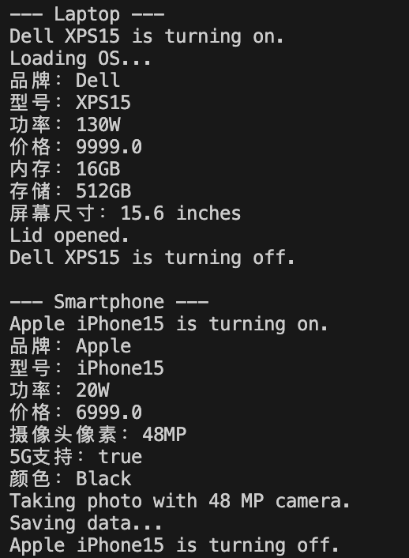
2.
package Practice;

public class Vehical
{
public String ownerName;
protected String licensePlate;
int wheels;
private double fuelCapacity;

public Vehical(String ownerName, String licensePlate, int wheels, double fuelCapacity)
{
this.ownerName = ownerName;
this.licensePlate = licensePlate;
this.wheels = wheels;
this.fuelCapacity = fuelCapacity;
}

public void start()
{
System.out.println(ownerName + "'s vehical is starting.");
}

public void stop()
{
System.out.println("Vehical is stopping.");
}

public void showDetails()
{
System.out.println("Owner: " + ownerName);
System.out.println("Plate: " + licensePlate);
System.out.println("Wheels: " + wheels);
System.out.println("Fuel: " + fuelCapacity + "L");
}
}

class Car extends Vehical
{
private String transmissionType;
private int seatCount;
boolean hasSunroof;

public Car(String ownerName, String licensePlate, int wheels, double fuelCapacity, String transmissionType, int seatCount, boolean hasSunroof)
{
super(ownerName, licensePlate, wheels, fuelCapacity);
this.transmissionType = transmissionType;
this.seatCount = seatCount;
this.hasSunroof = hasSunroof;
}

@Override
public void start()
{
System.out.println(ownerName + "'s car engine roars to life.");
}

@Override
public void showDetails()
{
super.showDetails();
System.out.println("Transmission: " + transmissionType);
System.out.println("Seat: " + seatCount);
System.out.println("Sunroof: " + hasSunroof);
}

public void honk()
{
System.out.println("Beep beep!");
}
}

class Motorcycle extends Vehical
{
private boolean hasSidecar;
private int engineCC;
String type;

public Motorcycle(String ownerName, String licensePlate, int wheels, double fuelCapacity, boolean hasSidecar, int engineCC, String type)
{
super(ownerName, licensePlate, wheels, fuelCapacity);
this.hasSidecar = hasSidecar;
this.engineCC = engineCC;
this.type = type;
}

@Override
public void stop()
{
System.out.println("Motorcycle brakes screech!");
super.stop();
}

@Override
public void showDetails()
{
super.showDetails();
System.out.println("Sidecar: " + hasSidecar);
System.out.println("Engine: " + engineCC + "cc");
System.out.println("Type: " + type);
}

public void wheelie()
{
System.out.println("Doing a wheelie!");
}
}
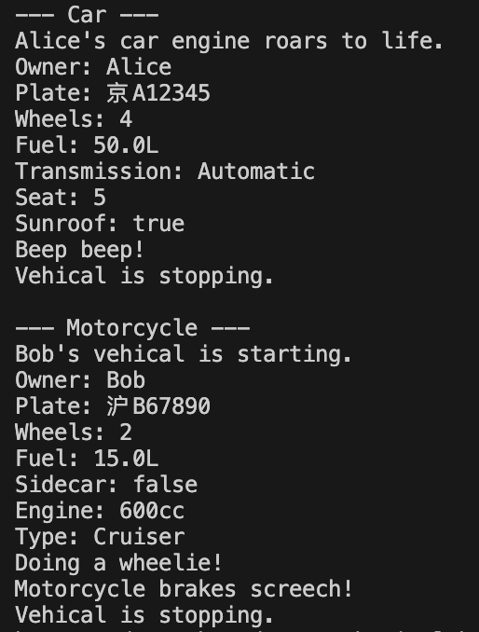

3.

4【实验要求】
将本次实验报告文件命名为“Java实验4(7)_学号_姓名”上交。

